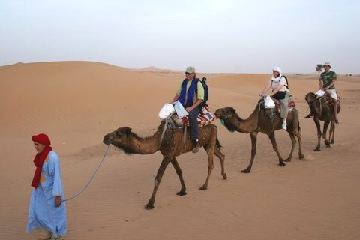
PRESS KIT

Richard Bangs’ Adventures with Purpose
“Morocco: Quest for the Kasbah”
“Norway: Quest for the Viking Spirit”

Dynamic, new American Public Television specials
that show viewers how they can make a difference

2/60 in HD & NTSC Letterboxed

Beautifully photographed and edited in HDTV

Programming that celebrates heroes of the earth

Award-winning specials that encourage adventure and eco travel

From Small World Productions, KCTS/Seattle, & Richard Bangs’ Productions

Richard Bangs’ Adventures with Purpose
“Morocco: Quest for the Kasbah” & “Norway: Quest for the Viking Spirit”
PRESS KIT
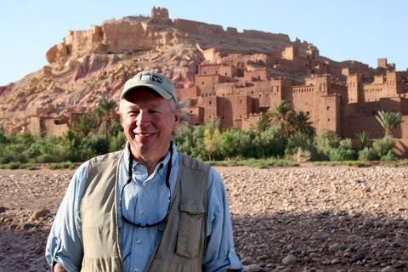
- Fact Sheets and Press Releases

- Bios for Richard Bangs & Small World Productions

- Pittsburgh Post-Gazette and NY Times profiles of Richard

- CD-ROM with MS Word files of press kit and photos

- Morocco: Quest for the Kasbah DVD

Program Descriptions:

Adventures with Purpose—Morocco: Quest for the Kasbah follows modern explorer Richard Bangs through an intoxicating intersection of great civilizations, as he seeks the meaning of today’s Kasbah and what it might represent for modern Morocco and the world. In this one-hour documentary, Richard begins his journey in Marrakesh, dips down to the Atlantic Coast at Essaouria, travels over the Atlas Mountains, and overnights in a nomad tent in the Sahara. Then he works his way north to Fès, Tangier, and Rabat, ending in the redoubtable city of Casablanca.

Adventures with Purpose—Norway: Quest for the Viking Spirit A thousand years ago Vikings set out from the fjords of Norway striking fear across Europe. Yet today this ruggedly beautiful country is the home of the Nobel Peace Center, of explorers and adventure travelers and is one of the most eco-friendly countries on earth. Richard’s quest is to discover how such a progressive nation grew from such a violent past. His goal is to find out if modern Norway is a result of its Viking heritage or a reaction to it. Bangs’ adventures take him the length of Norway from its forbidding Arctic north, to its mountainous sea coast and its bustling modern cities with stops in Oslo, Alta, Kirkenes and Lofotr. Like the early Vikings he sails from Tromsø down the western cost of Norway and experiences the beauty and majesty of the mountains and fjords in Trondheim, Bergen, Flam and on the Sognefjord.

Recent Awards:


A New York Times article by Richard won a 2007 Lowell Thomas Award for travel journalism.

In 2007, Richard was honored with the Mark Dubois Award, a lifetime achievement award from Friends of the River. The Dubois Award recognizes Richard’s contributions to worldwide river and wilderness conservation.

Previous Adventures with Purpose documentary honors include: “New Zealand: Quest for Kaitiakitanga” was recognized with a 2008 CINE Golden Eagle Award and has been nominated for a 2008 Environmental Media Association Award—the “Green Oscars;” “Egypt: Quest for the Lord of the Nile,” won two 2007 Silver Telly Awards, one as a documentary and one in the travel and tourism category.

